Periodical Cicada Fieldtrip
Location: Walworth County, Big Foot Beach State Park
Date: TBA, Tentative 6/1/24 OR 6/8/24
Time: 11:00 AM - 1:30 PM
Transportation: Meet at the park. 1550 S Lake Shore Drive, Lake Geneva, WI 53147
Send an email to wimetrobird@gmail.com to receive updates.
Register on this Form: https://forms.gle/awjaad7dJLvy5YtF9

2024 is an especially exciting year for the 17 year cicada. This year Brood XIII will emerge in Northern Illinois and a few areas in the Lake Geneva, WI area. According to Cicada Mania ,
not since the Thomas Jefferson presidency (1803) has a 13 year cicada, Brood XIX also emerged in Illinois and Indiana at the same time.
Of all the states where the broods will emerge this year, they are expected to overlap in Illinois and Indiana.
In 2007, WMAS board member, Pat Fojut was lucky enough to visit Big Foot Beach State Park in Lake Geneva. We saw more than a thousand cicadas climbing up trees and emerging from the ground. I am planning a fieldtrip to explore the area including how birds take advantage of a rare food source (Every 17 years!). The insects emerge together for about a month and there is evidence that this starts when the soil temperature is 64 F in the spring. The tentative dates will be either Saturday 6/1/24 OR 6/8/24 with Rain dates on 6/2 OR 6/9 respectively. The date will be determined closer to the end of May with the help of Lakeland Audubon Society. We will meet at Big Foot Beach state park at 11:00 am. A park sticker is required. Expect mosquitos and flying insects, wear protective clothing, long sleeves, solid shoes, hat and water. This fieldtrip is sponsored by WI Metro Audubon Society and Lakeland Audubon Society.
We will have a Cicada Safari station to get local Cicada information and park locations to explore. You are welcome to stay as long as you enjoy the experience.

Lakeland Audubon Society – A local chapter of the National Audubon Society serving Walworth County, Wisconsin and the surrounding areas

WMAS (wisconsinmetroaudubonsociety.org)

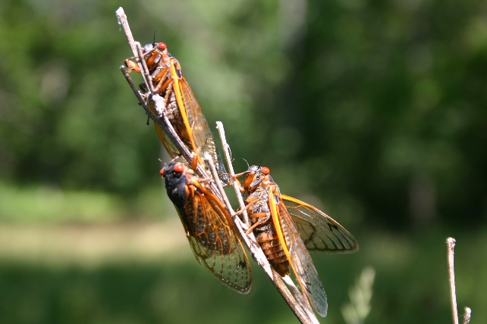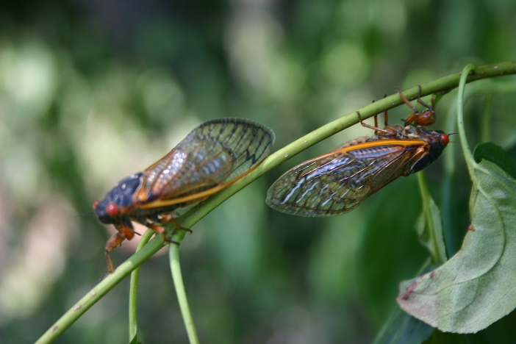
17 year cicada, Lake Geneva, WI June, 2007

